19.60: a)

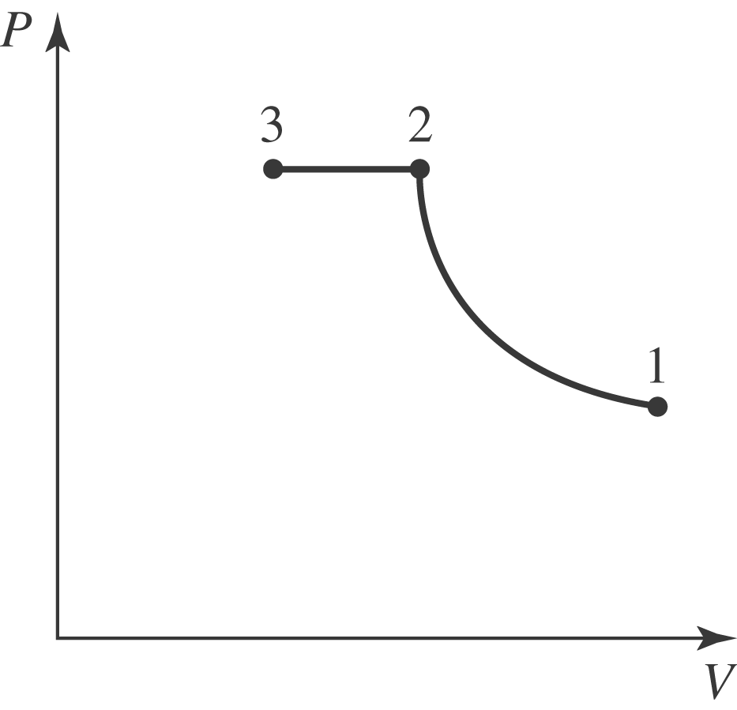

b) The final temperature is the same as the initial temperature, and the density is proportional to the absolute pressure. The mass needed to fill the cylinder is then

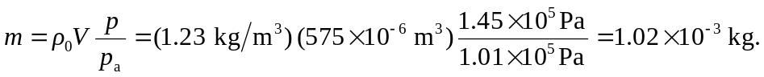

The increase in power is proportional to the increase in pressure; the percentage increases is 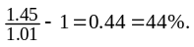 c) The temperature of the compressed air is not the same as the original temperature; the density is proportional to the pressure, and for the process, and modeled as abiabatic, the volumes are related to the pressure by Eq. (19.24), and the mass of air needed to fill the cylinder is

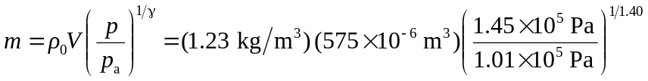
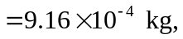

an increase of 